TEXT PHOTO EFFECT…EASY LOGO IDEA!

- Select a portrait and remove the body from the background. Press the W key to select the QUICK SELECTION tool. The + plus sign adds to the selection, holding the ALT key changes the brush to – minus from the selection. Please wrap the dotted lines around the edge of the portrait.
- Next please select the MASK icon and you will see a thumbnail of your selection as a black and white silhouette mask.
- Let’s refine the edges of our portrait to clean up the hair and other small areas. Begin by placing your cursor over the mask thumbnail and RIGHT-CLICK choose SELCT and MASK. On the right is your tool bar for Select and Mask please select the REFINE EDGE brush. Use the brush to paint around the edges of the hair and others areas that need refinement. When done click OK.
- Now please add a white background. Click the NEW LAYER icon then make sure WHITE is your foreground color, use the bucket tool, and click the empty area around your portrait to fill. Drag this new layer below the Portrait layer.
- HELPFUL TIP…we are working a lot in Photoshop and you might want a backup layer sometimes. Select your portrait layer and create a copy with CTRL+J but then name it BACKUP and drag it to the bottom below the White layer.
- Resize the portrait layer as needed with CTRL+T at anytime. Make sure you have selected the portrait layer!
- Make sure your top layer is selected and then we are using the TEXT TOOL, which is located in the tool bar and has the large letter T. Please select the vertical type tool by holding down the large T. At the top menu bar there is a small square of color, click it and choose black. This is the font color.
- With the first image please choose a bold face, thick text letter font then choose a 4-5 letter word and type it. Please click the check mark to confirm your done typing. Don’t worry about the font size. We will use CTRL+T free transform while holding the SHIFT key to size it as needed.
- Align the text along side half of the portrait (right of left) but make sure the text has at least a portion of the portrait underneath it but the top letter should be just touching the top of the portrait.
- Now please select the layer with the portrait thumbnail and the mask and PAY ATTENTION! Click the mask thumbnail and brush black inside the text only. Like the inside of a letter O, or B, D, etc…It should turn white. Then also paint to remove the portrait along the left or right side of the text.
- Now we need to make a selection of the text. While the MASK of the portrait is selected (white brackets are over it) Please CTRL Click the TEXT layer which will make a selection (little dotted lines) around the text.
- Go to the menu bar and choose SELECT>MODIFY>EXPAND and type 10 for the pixels.
- With the Portrait MASK still selected make sure your foreground color is BLACK and click ALT+BACKSPACE. Everything inside the selection will be erased. Press CTRL+D to Deselect the text.
- Now make a copy of your Portrait Layer CTRL+J and drag it above the TEXT layer you created. Then RIGHT-CLICK on the layer MASK of the copy you just made and DELETE LAYER MASK. You should see the entire Portrait Image now.
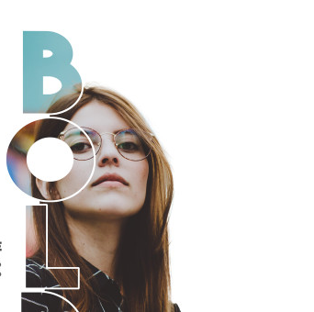
- Please RIGHT-CLICK the Portrait layer copy and select CREATE CLIPPING MASK. WOW, the photo should only show up within the text now.
- Save as a .JPEG and you are done!

